1. Introduction to Python

Table of Contents

|  |  |  |
| --- | --- | --- |
| Sl. No | Topics | Page No |
| 1.1 | **Programming Languages Overview** | **2** |
| 1.2 | **Understanding Python** | **9** |
| 1.3 | **Python Installation** | **15** |
| 1.4 | **Top 10 reasons for learning Python** | **23** |
| 1.5 | **Why Python is the ultimate choice for Data Science Career** | **33** |

## 1.1 Programming Languages Overview

**What is Programming Language? What are its types?**

* A **Programming Language** is a [formal language](https://en.wikipedia.org/wiki/Formal_language), which comprises a [set of instructions](https://en.wikipedia.org/wiki/Instruction_set) used to produce various kinds of [output](https://en.wikipedia.org/wiki/Input/output).
* Programming languages are used in [computer programming](https://en.wikipedia.org/wiki/Computer_programming) to create [programs](https://en.wikipedia.org/wiki/Program_(machine)) that implement specific [algorithms](https://en.wikipedia.org/wiki/Algorithm).
* There are three types of programming languages
  + Machine Languages
  + Assembly Languages
  + High Level Languages

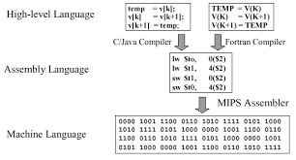

**What is Machine Language?**

* A computer is an electronic machine which can understand any instruction written in binary form. i.e., 0’s and 1’s.
* The lowest-level programming language, machine languages are the only languages understand by computers.
* While easily understood by computers, machine languages are almost impossible for humans to use because they consist entirely of numbers. An assembly language contains the same instructions as a machine language, but the instructions and variables have names instead of being just numbers. Assembly language programs are translated to machine language by a program called an Assembler.
* Every CPU has its own unique machine language. Programs must be rewritten or recompiled, therefore, to run on different types of computers.

**What is an Assembly Language?**

* An **assembly** (or **assembler**) **language**,[[1]](https://en.wikipedia.org/wiki/Assembly_language) often abbreviated **asm**, is any [low-level programming language](https://en.wikipedia.org/wiki/Low-level_programming_language) in which there is a very strong correspondence between the program's statements and the [architecture's](https://en.wikipedia.org/wiki/Computer_architecture) [machine code](https://en.wikipedia.org/wiki/Machine_code) [instructions](https://en.wikipedia.org/wiki/Instruction_set_architecture).[[2]](https://en.wikipedia.org/wiki/Assembly_language)
* Assembly code is converted into executable machine code by a [utility program](https://en.wikipedia.org/wiki/Utility_software) referred to as an [*assembler*](https://en.wikipedia.org/wiki/Assembly_language). The conversion process is referred to as *assembly*, or *assembling* the [source code](https://en.wikipedia.org/wiki/Source_code).
* Assembly language is just one level higher than machine language. Language for Computers, Microprocessors, Microcontrollers and other programmable devices.

**What is High Level Language?**

* A program written in high-level language is called Source-Code.
* The process of executing programswritten in high level languages as given below:-
* **Compiler:** Used to translate a program written in high level language into equivalent machine code for execution.
* **Linker:** Used to combine the object code and the code is stored in libraries into Machine Language.
* **Loader:** To load, assign the storage space for executable program in the memory to execute.

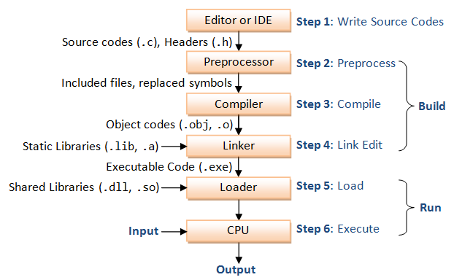

**What are the different programming languages?**

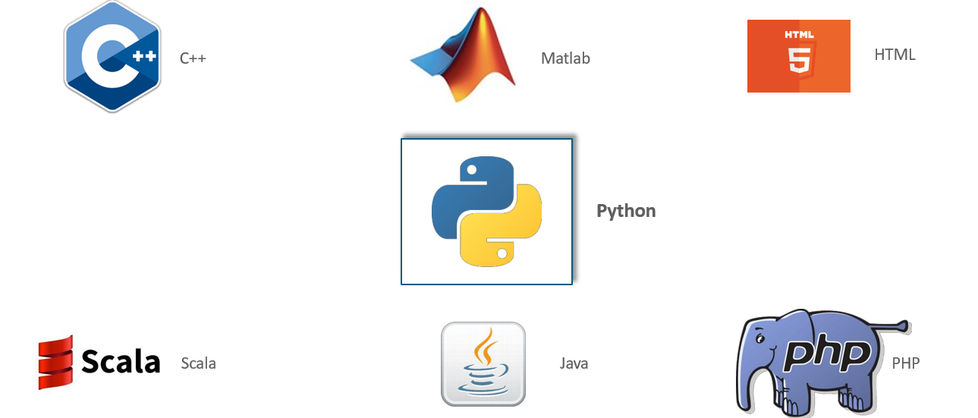

**What are the top programming languages?**

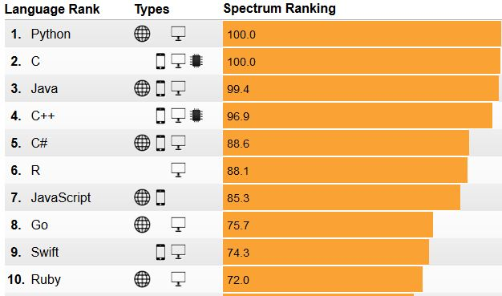

**What is the need of programming?**

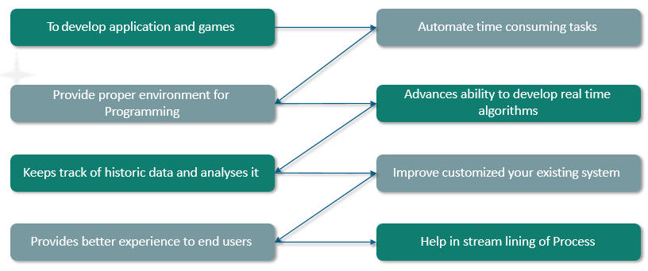

**What are the advantages of Programming?**

|  |  |
| --- | --- |
| With Out Computer Programs | With Computer Programs |
| Communicate with others: 3-4 days for sending a letter to someone even in the same district and it costs money | Less than 1-minute to send an email to any place in the world at no cost |
| Booking Railway Tickets: Stand in really long queues. Can reserve railway tickets only for the quota of that station. Even if other stations quota is not filled, we cannot reserve the tickets. Can only book tickets from that station and cannot book return tickets | Can book tickets from anywhere to anywhere, sitting at home |
| Sending money from parent to the child studying in a  college: This involves the parent going to the bank for the DD, send it to the student by post, student submitting the DD in the bank, wait for the DD to clear and withdraw the money by showing the passbook and filling an withdrawal form | The money transfer is almost instant and money can be withdrawn from any ATM |
| Seat allocation in engineering college: Go to the counselling center far away from your town, wait for hours together for your turn, but make the decision of which college and branch to choose in less than 5 minutes | Have lots of time to research the colleges, decide upon the colleges and branches, review them multiple people and submit it online with peace of mind |

**Why Python? What is the importance of Python?**

|  |  |
| --- | --- |
| Importance of Python | |
| Simple and Easy to Learn  Python is simple and easy to learn, read & write |  |
| Free and Open Source  Python is an example of a FLOSS (Free/Libre and Open Source Software) which means one can freely distribute copies of this software, read its source code, modify it, etc. |  |
| High-level Language  One does not need to bother about the low-level details like memory allocation, etc. while writing a Python script |  |
| Portable  Supported by many platforms like Linux, Windows, FreeBSD, Macintosh, Solaris, BeOS, OS/390, PlayStation, Windows CE, etc. |  |
| Supports different Programming Paradigm  Python supports procedure-oriented programming as well as object- oriented programming |  |
| Extensible  Python code can invoke C and C++ libraries, can be called from and C++ programs,  can integrate with Java and .NET components |  |

**What are the benefits of Python?**

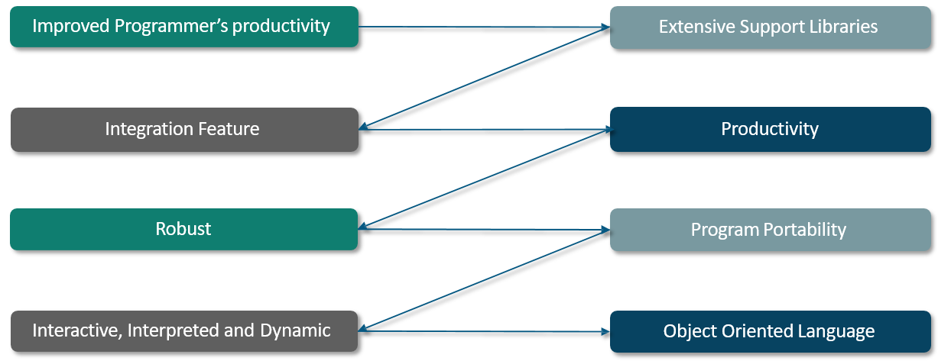

**Who is using Python?**

**What are the Python Applications?**

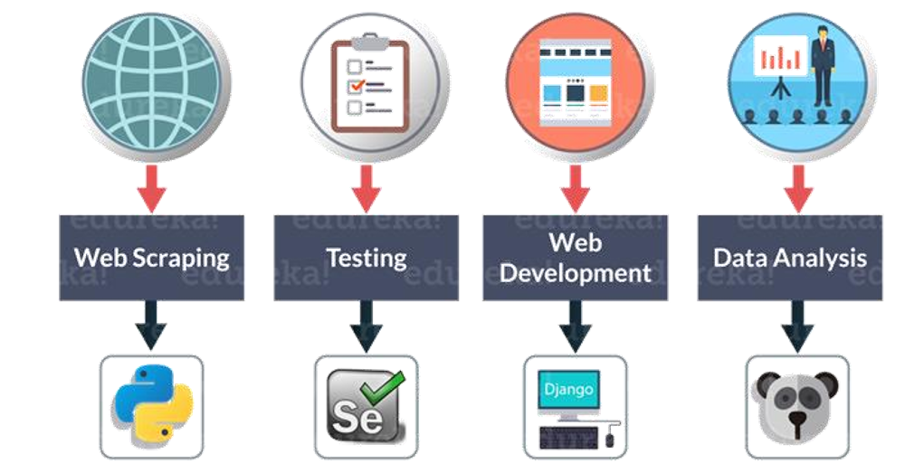

**Do you know different domains catered by Python?**

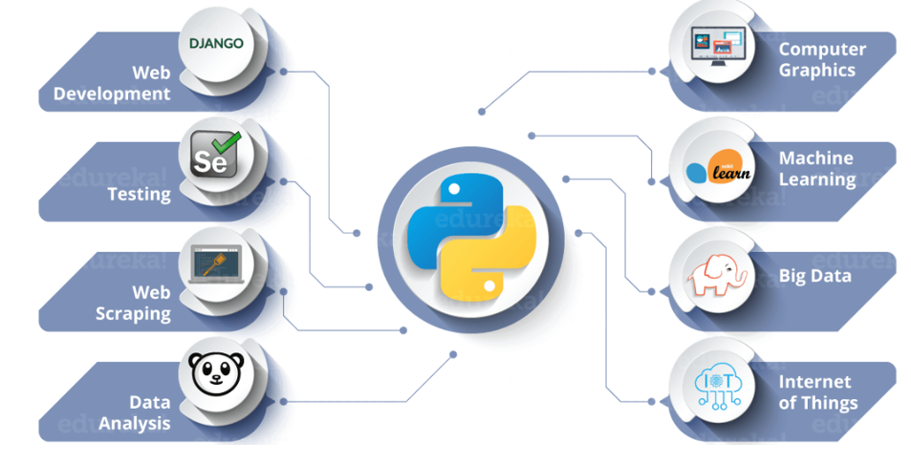

## 1.2 Understanding Python

**Who invented Python? Who is the author of Python?**

* **Guido Van Rossum:**A Dutch programmer, popularly known as the author of Python programming language. He has created Python in 1989 and has worked for *Google*and *Dropbox!*



**What is Python?**

* **Python** is an [interpreted](https://en.wikipedia.org/wiki/Interpreted_language), [high-level](https://en.wikipedia.org/wiki/High-level_programming_language), [general-purpose programming language](https://en.wikipedia.org/wiki/General-purpose_programming_language). Created by [Guido van Rossum](https://en.wikipedia.org/wiki/Guido_van_Rossum) and first released in National Research Institute at Netherland in 1991
* Python features a [dynamic type](https://en.wikipedia.org/wiki/Dynamic_type) system and automatic [memory management](https://en.wikipedia.org/wiki/Memory_management). It supports multiple [programming paradigms](https://en.wikipedia.org/wiki/Programming_paradigm), including [object-oriented](https://en.wikipedia.org/wiki/Object-oriented_programming), [imperative](https://en.wikipedia.org/wiki/Imperative_programming), [functional](https://en.wikipedia.org/wiki/Functional_programming) and [procedural](https://en.wikipedia.org/wiki/Procedural_programming), and has a large and comprehensive [standard library](https://en.wikipedia.org/wiki/Standard_library)

**Is it Python is an Interpreter Language?**

* Python Interpreter is a program that reads and executes code
* This includes source code, pre-compiled code and scripts
* Example: **help(‘for’)**

**What are the features of Python?**

The features of Python are:-

* Easy
* Expressive
* Free & Open Source
* High Level
* Portable
* Object Oriented
* Extensible
* Embeddable
* Interpreted
* Large Standard Library
* GUI Programming
* Dynamically Typed



**How Python gets executed?**

When a programmer tries to run a Python code as a script or instructions in an interactive manner in a Python Shell, then Python performs various operations step by step internally.

* **Step 1:** The Interpreter **reads a Python code or instruction from source file with .py extension**. Then it verifies that the instruction is well formatted by checking the syntax of each line. Suppose if it encounters any error, it immediately halts the translation and shows an error message.
* **Step 2:** If there is no error, the interpreter translates it into its equivalent form in low level language called “**Byte Code**”. After successful execution of Python script or code, it is completely translated into byte code.
* **Step 3:** Byte code is sent to the **Python Virtual Machine** (**PVM**). Here again the byte code is executed on PVM. If an error occurs during this execution then the execution is halted with an error message.

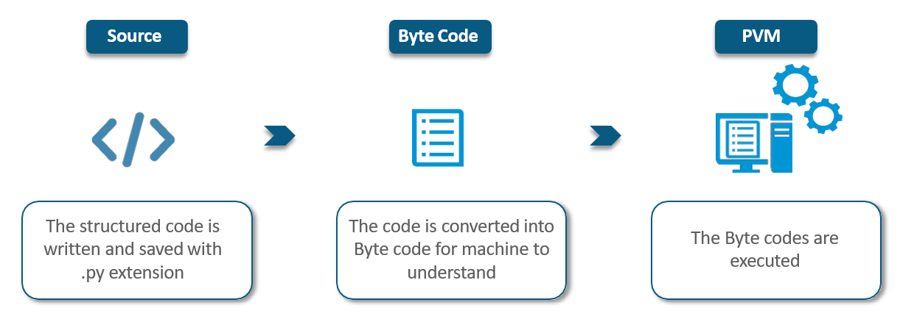

**Ever Wondered Why is it named Python?**

There’s an interesting story about it. While implementing Python, *Van Rossum* was also reading the published scripts from **“*Monty Python’s Flying Circus*”**, a *BBC* *comedy series* from the 1970s. Since he wanted a short, unique and slightly mysterious name for his invention, he got inspired by the series and named it **Python**!

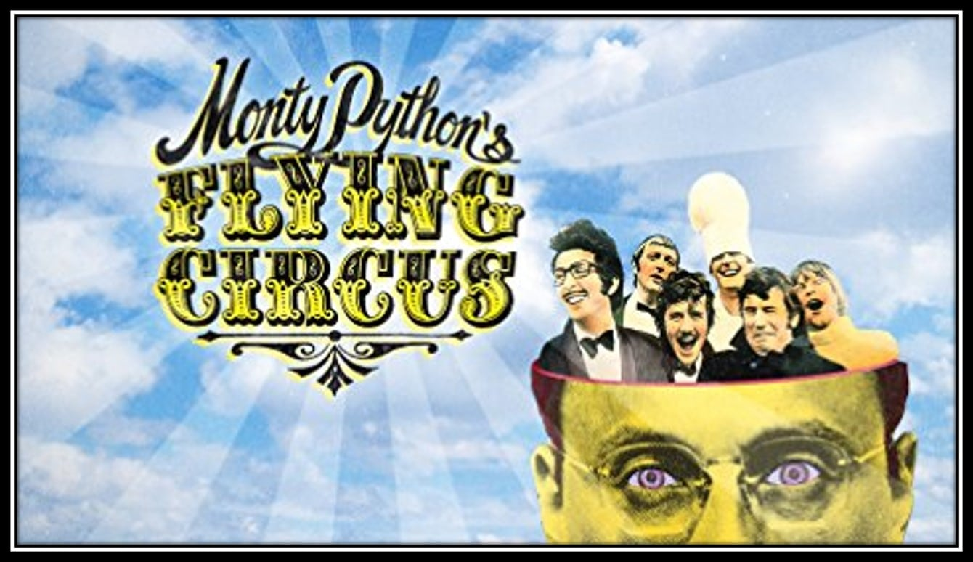

**What are the concepts borrowed from the other languages?**

The concepts borrowed from other languages are:-

* Functional Programming from C
* OOPs from C++
* Scripting from Perl and Shell Script
* Modular features from Modula 3
* Syntax from C and ABC language

**What are the uses of Python?**

The Python uses are:-

* Desktop Application
* Web Application(Django)
* Database Application
* Network Application
* Games
* Data Analysis using Numpy, Pandas,
* Machine Learning using Scikit,..
* Artificial Intelligence using TensorFlow, Caffe, Keras,
* IoT

**What are the versions of Python?**

The Versions of Python are:-

* Python 1 introduced in Jan 1994
* Python 2.0 introduced in Oct 2000
* Python 3.0 introduced in Dec 2008
* Any new version should provide support for old version program exception in python
* Python 3 is not backward compatibility with Python 2.
* Note: Python 2 support is not supported after 2020

**What are the limitations of Python?**

The limitations of Python are:-

* Weak in Mobile Computing
* Get slow in speed
* Run time errors
* Underdeveloped Database Access Layers

**What are the flavors of Python?**

|  |  |
| --- | --- |
| The flavors of Python are:-   * CPython – Cython * JPython – Jython * Iron Python * PyPython - Performance using JIT * RubyPython * Anaconda * Stackless (Python for concurrency) |  |
|  |  |

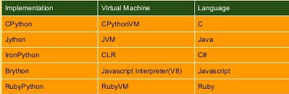

**Is Python a scripting language?**

'Yes' ''' A scripting language usually doesn’t need to be compiled to run as you write some meaningful code. Microsoft excel may be built using C++ language but it exposes a scripting language called Visual Basic for Applications, for users to define their custom functionality.

Similarly web browsers may be built with C++/Java language but they expose a scripting language called javascript. A scripting language generally sits behind some programming language. Scripting languages generally have less access to the computer’s native abilities since they only run on a subset of the programming language. Scripting languages may have less access and are slower compared to programming languages, but they can be very powerful programming tools. '''

## 1.3 Python Installation

**What are the environment in Python?**

* **Immediate mode:** From Command Prompt(cmd): Type "python"
* **Script Mode:** python file.py
* **Integrated Development Environment (IDE) Mode:** pycharm, jupyter notebook, spyder

**Note:**

* + “pycharm” is used for production environment.
  + Anaconda is a Navigator to use jupyter notebook & spyder

**What are the steps Installing Python?**

* Download Python from the link : [https://www.python.org/downloads/](https://www.anaconda.com/download/)

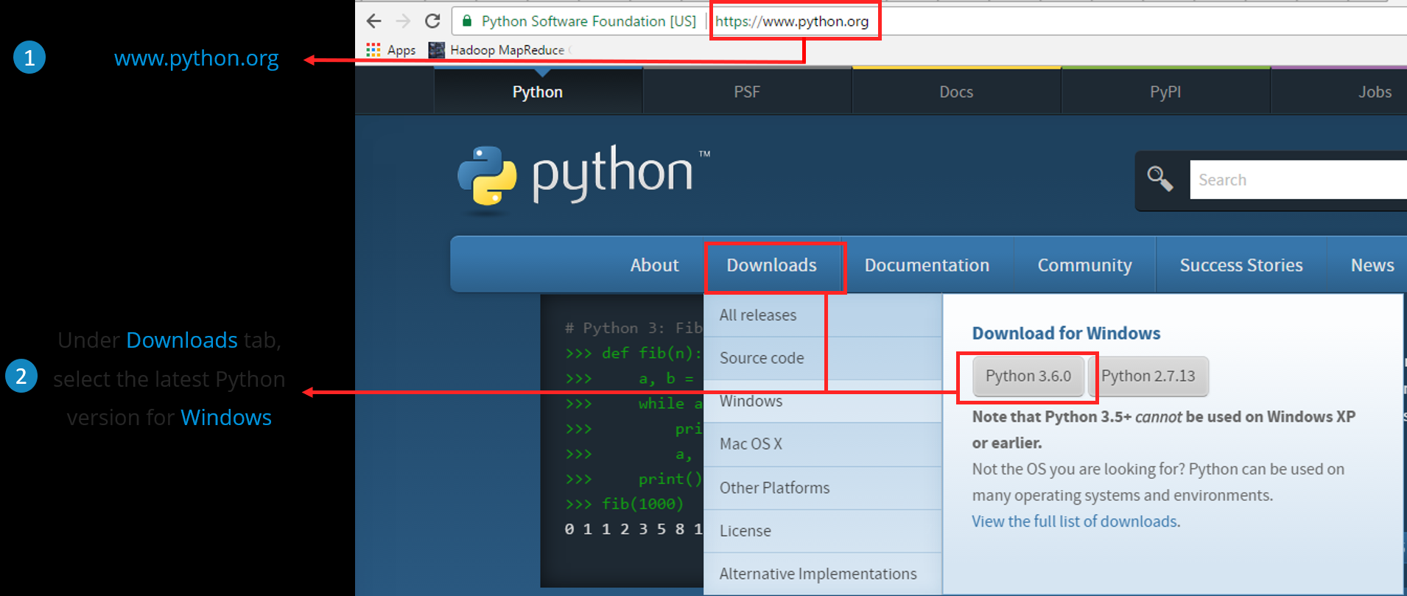

* Select the Operating System and also the version of Python. Currently downloading 3.6.0 in my windows machine.

**Link to download Python for windows:** <https://www.python.org/downloads/windows/>

* Open the downloaded **Python installer** and click on “**Run**”

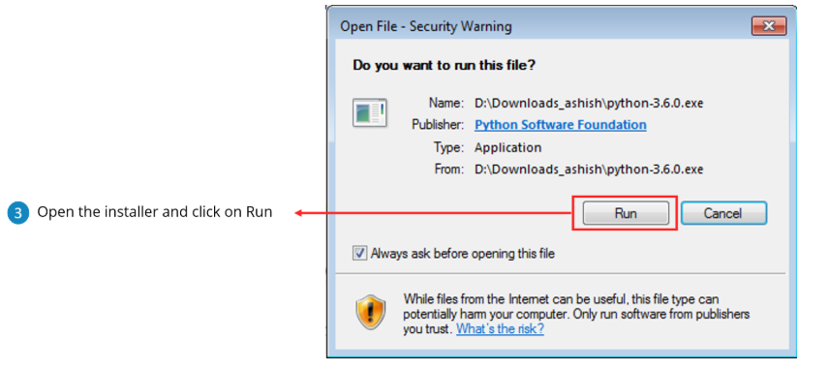

* Click on “**Install Now**” and check on “**Add Python 3.6 to PATH**”

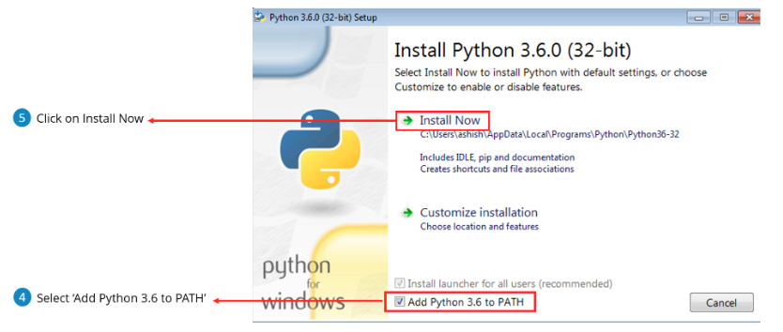

* Start IDLE which is a Python GUI and start scripting.

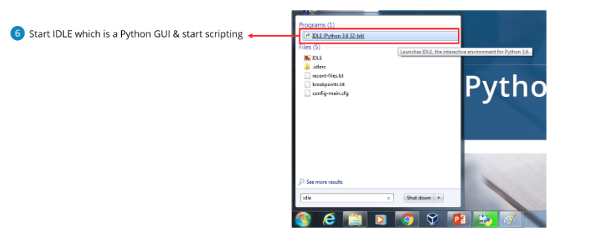

* To verify the Python program is installed, type “Python” in Search bar the pop up will appear like this..

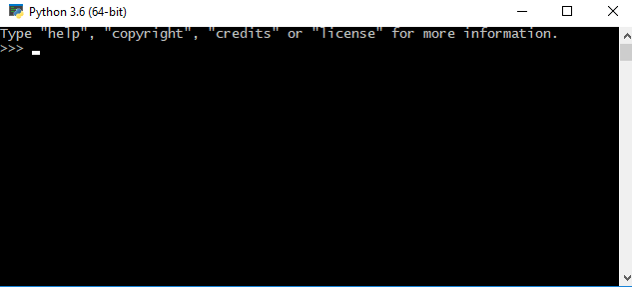

* Python Installation Verification in Command Prompt

You need to write python in command prompt for automatic installation of all packages. Once this is done, you can write your code.



**What are the packages needs to install for Python?**

To install python packages, refer <https://www.makeuseof.com/tag/install-pip-for-python/>

**IDE Installation**

* IDE typically provides code editor, compiler/ interpreter and debugger in one GUI (Graphical User Interface). It encapsulates the entire process of code creation, compilation and testing which increases the productivity of developers. **In IDE, No need to install separate packages for Python.**
* A developer working with an IDE starts with a model, which the IDE translates into suitable code. The IDE then debugs and tests the model-driven code, with a high level of automation. Once the build is successful and properly tested, it can be deployed for further testing through the IDE or other tools outside of the IDE.
* Most of them won’t prefer using IDLE for coding in Python, instead they will use **PyCharm for production** purpose, and you can use any other IDE that you want **Jupyter Notebook, Spyder** by installing **Anaconda Navigator.**

**Pycharm Installation**

* Download PyCharm from the link  [www.jetbrains.com/pycharm/download/#section=windows](http://www.jetbrains.com/pycharm/download/)
* Here, the community version is free, but for the professional version, you need to buy the license. I will be working on the PyCharm community version.

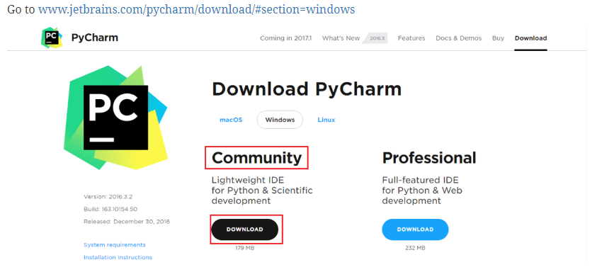

**Anaconda Installation**

* Download Python from the link : <https://www.anaconda.com/download/>
* Step by step for Anaconda Installation

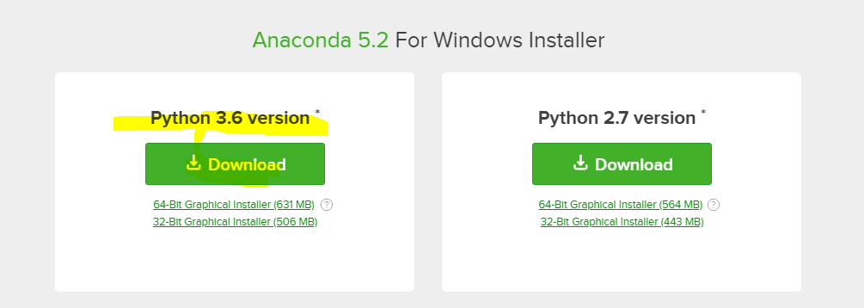

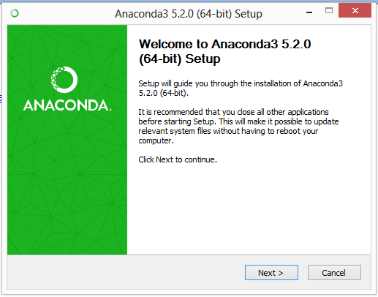

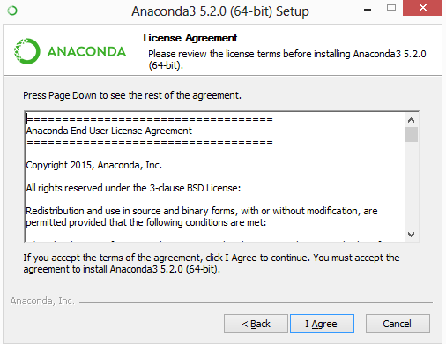

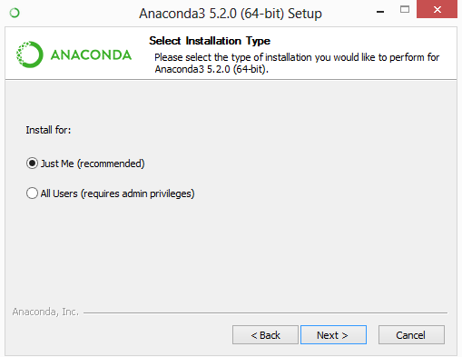

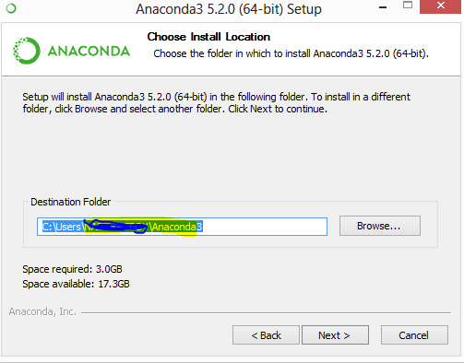

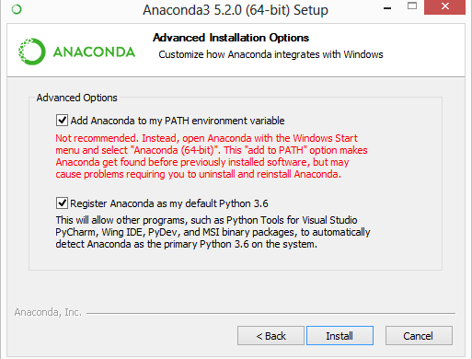

Installation in Progress..

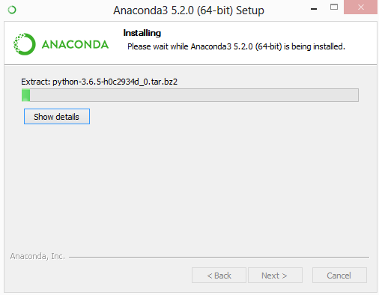

## 1.4 Top 10 Reasons to learn Python

**What are the Top 10 reason to learn Python?**

The top 10 reason to learn Python:-

1. Python’s popularity & high salary
2. Python is used in Data Science
3. Python’s scripting & automation
4. Python used with Big Data
5. Python supports Testing
6. Computer Graphics in Python
7. Python used in Artificial Intelligence
8. Python in Web Development
9. Python is portable & extensible
10. Python is simple & easy to learn

**10. Python is simple & easy to learn**

Python is extremely simple and easy to learn. It is a very powerful language and it closely resembles the English language! So, what contributes to its simplicity? Python is

* + Free & open source
  + High-level
  + Interpreted
  + Blessed with large community

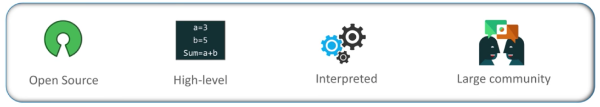

* Furthermore, in Python, you don’t have to deal with complex syntax compared to Java

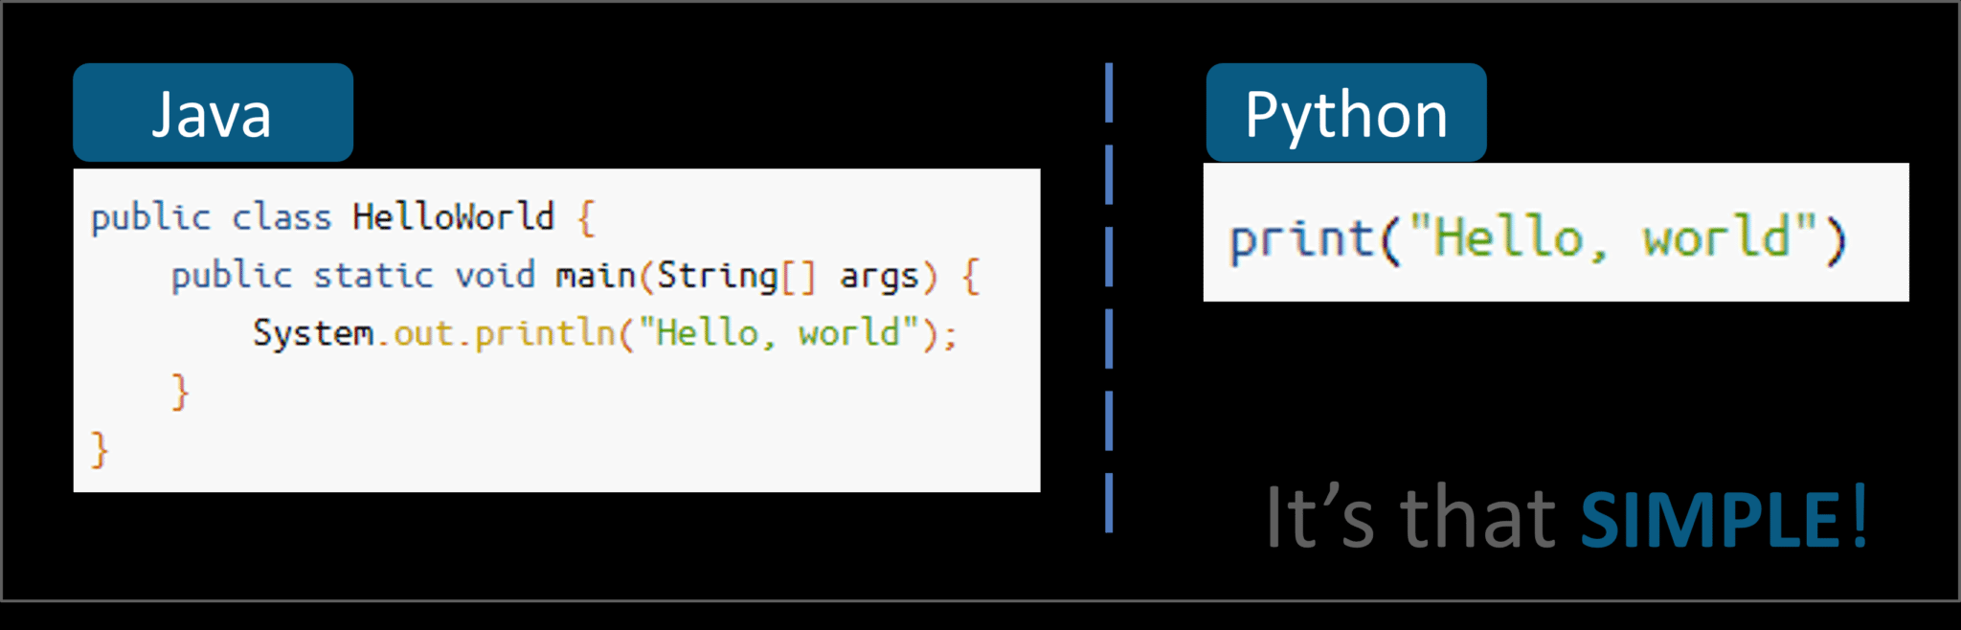

* The main reason is **Simplicity of the Code which makes the best suit for beginners**.

**9. Python is portable & extensible**

* The portable and extensible properties of Python allow you to perform cross-language operations seamlessly. Python is supported by most platforms present in the industry today ranging from Windows to Linux to Macintosh, Solaris, Play station, among others.
* Python’s extensibility features allow you to integrate Java as well as .NET components. You can also invoke C and C++ libraries.

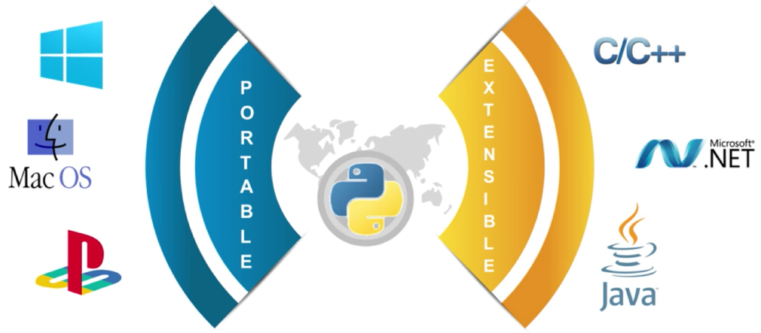

**8 Python in Web Development**

* Python has an array of frameworks for **developing websites**. The popular frameworks are Django, Flask, and Pylons etc. Since these frameworks are written in Python, it’s the core reason which makes the code a lot faster and stable.
* You can also perform **web scraping** where you can fetch details from any other websites. You will also be impressed as many websites such as Instagram, bit bucket, Pinterest are build on these frameworks only.

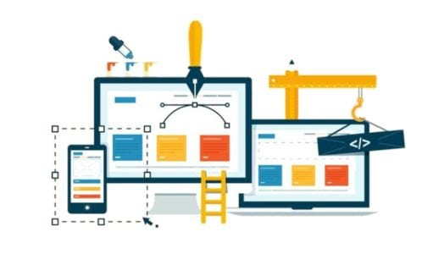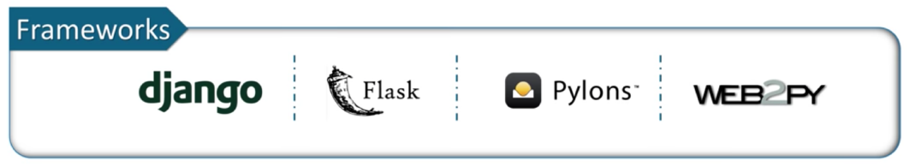

**7. Python used in Artificial Intelligence**

* AI is the next huge development in the tech world. You can actually make a machine mimic the human brain which has the power to think, analyse and make decisions.
* Furthermore, libraries such as Keras and TensorFlow bring machine learning functionality into the mix. It gives the ability to learn without being explicitly programmed. Also, we have libraries such as openCv that helps computer vision or image recognition.

|  |  |
| --- | --- |
|  |  |

**6. Computer Graphics in Python**

* Python is largely used in small, large, online or offline projects. It is used to build GUI and desktop applications. It uses ‘Tkinter‘library to provide fast & easy way to create applications.
* It is also used in game development where you can write the logic of using a module ‘pygame’ which also runs on android devices.

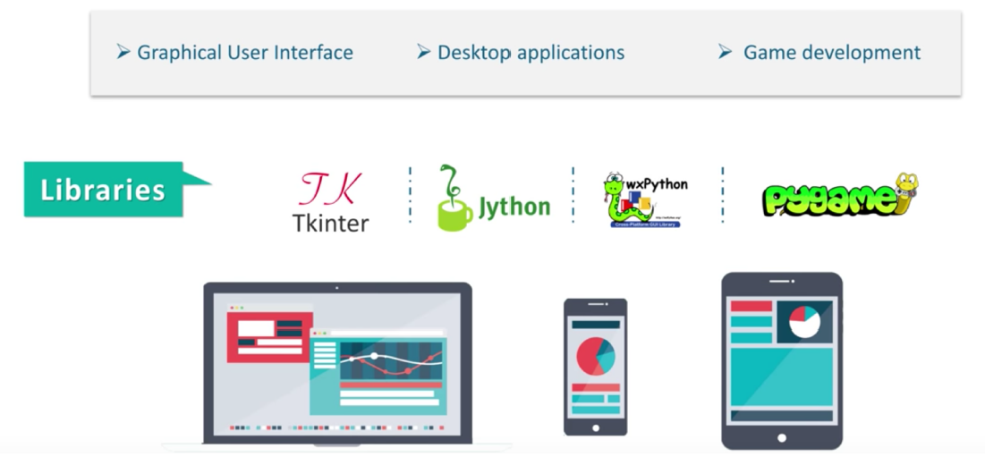

**5 Python Supports Testing**

* Python is great for validating ideas or products for established companies. Python has many built-in testing frameworks that covers **debugging & fastest workflows**. There are a lot of tools and modules to make things easier such as Selenium and Splinter.
* It supports testing with **cross-platform & cross-browser** with frameworks such as PyTest and Robot Framework. Testing is a tedious task and Python is the booster for it, so every tester should definitely go for it!

|  |  |
| --- | --- |
|  |  |

**4 Python used with Big Data**

* Python handles a lot of hassles of data. It supports **parallel computing** where you can use Python for **Hadoop** as well. In Python, you have a library called “Pydoop” and you can write a MapReduce program in Python and process data present in the HDFS cluster.
* There are other libraries such as ‘Dask‘and ‘Pyspark‘ for big data processing. Therefore, **Python is widely used for Big Data** where you can easily process it!

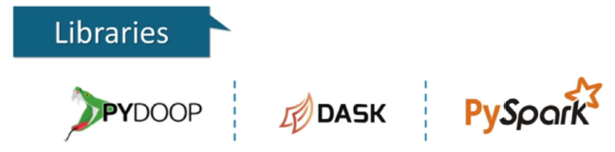

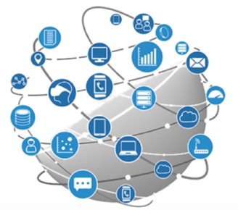

**3 Python Scripting & Automation**

* Many people only knows that Python is the programming language, but Python can also be used as a **most popular Scripting language**. In scripting:
  + The code is written in the form of scripts and get executed
  + Machine reads and interprets the code
  + Error checking is done during Runtime
* Once the code is checked, it can be used several times. So by automation, you can **automate certain tasks** in a program.
* They are **interpreted rather than compiled**.

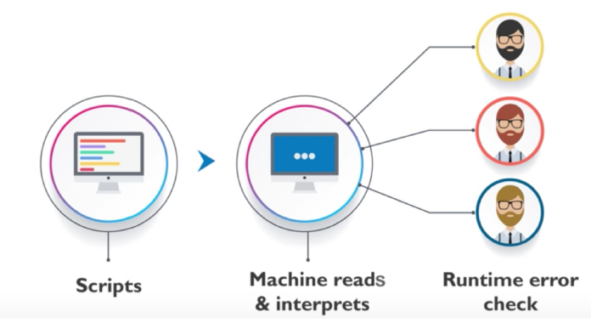

**2 Python is used in Data Science**

* Python is the leading language of many data scientist. For years, academic scholars and private researchers were using the MATLAB language for scientific research but it all started to change with the release of Python numerical engines such as ‘Numpy’ and ‘Pandas’.
* Python also deals with the **tabular, matrix as well as statistical data** and it even visualizes it with popular libraries such as ‘Matplotlib’ and ‘Seaborn‘.
* Python is well suited for data manipulation & analysis

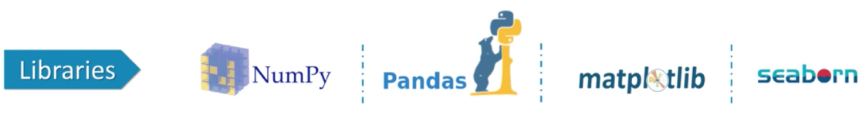

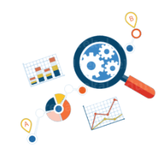

**1 Python’s Popularity and High Salary**

Python engineers have some of the highest salaries in the industry. The average Python Developer salary in the United States is approximately $116,028 per year.



Also, Python has a strong spike in popularity over the last 1year. Refer the below screenshot taken from Google Trends.

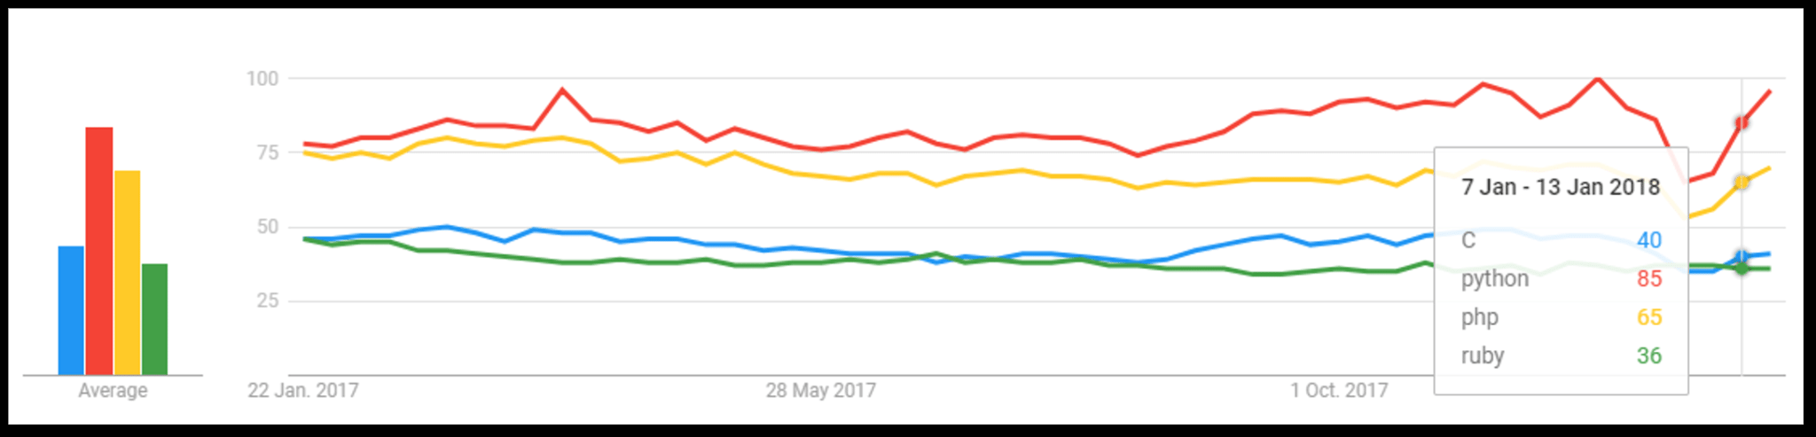

The New York Times reports a candidate shortage for certified AI Engineers, with fewer than 10,000 qualified people in the world to fill these jobs, which according to that, an average salary of **$172,000** per year in the U.S. for engineers with the required skills.

## 1.5 Why Python is the ultimate choice?

**Why Python is the ultimate choice for Data Science?**

Top Analytics/Data Science/ML Software in 2018 KDnuggets Poll

|  |  |
| --- | --- |
| Top Analytics Data Science Machine Learning Software 2018 3yrs |  |

**Why Python is the ultimate choice for Data Science?**

**Ref:**https://www.kdnuggets.com/2018/05/poll-tools-analytics-data-science-machine-learning-results.html

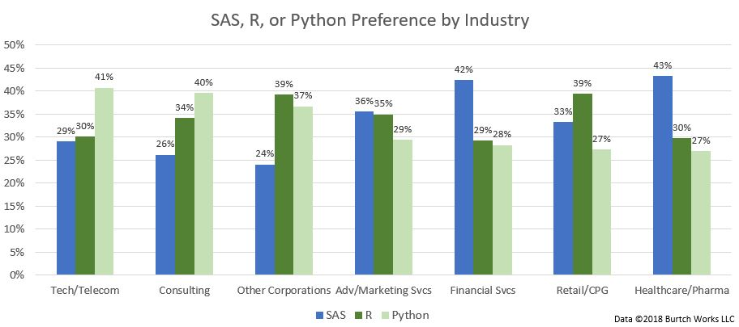

**What are the Top Machine Learning Tools for Data Science?**

Major Analytics/Data Science/ML Tools with the largest increase in usage

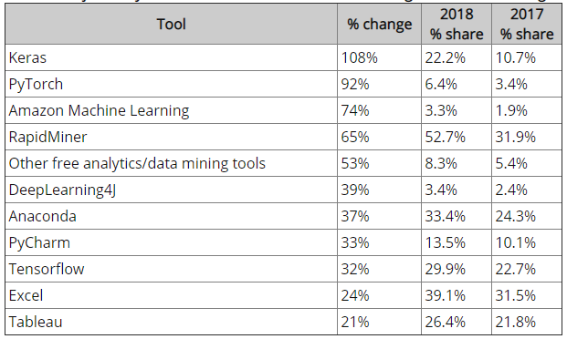

**What are the top Deep Learning Tools for Data Science?**

Major Analytics/Data Science/DL Tools with the largest increase in usage

|  |  |
| --- | --- |
| Top Deep Learning tools:-   * Tensorflow, 29.9% * Keras, 22.2% * PyTorch, 6.4% * Theano, 4.9% * Other Deep Learning Tools, 4.9% * DeepLearning4J, 3.4% * Microsoft Cognitive Toolkit (Prev. CNTK), 3.0% | * Apache MXnet, 1.5% * Caffe, 1.5% * Caffe2, 1.2% * TFLearn, 1.1% * Torch, 1.0% * Lasagne, 0.3% |

**Big Data Tool: Hadoop drops**

In 2018, about 33% used Big Data tools, either Hadoop or Spark - about the same as in 2017, but Hadoop usage has markedly declined - about 30%.

Here are the details

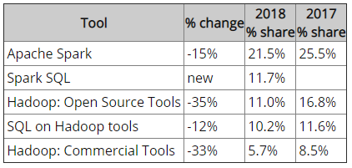

**Programming Language: Top 1 Python**

Python seems to swallow not only R, but also most other languages, except for SQL, Java, C/C++ which remained at about the same level. R has declined for the first time since we have run this survey. Other languages have also declined.   
  
Here are the main programming languages sorted by popularity:-

* Python, 65.6% (was 59.0% in 2017), 11% up
* R, 48.5% (was 56.6%), 14% down
* SQL, 39.6% (was 39.2%), 1% up
* Java, 15.1% (was 15.5%), 3% down
* Unix, shell/awk/gawk, 9.2% (was 10.8%), 15% down
* Other programming and data languages, 6.9%, (was 7.6%), -9% down
* C/C++, 6.8%, (was 7.1%), 3% down
* Scala, 5.9%, (was 8.3%), 29% down
* Perl, 1.0% (was 1.9%), 46% down
* Julia, 0.7% (was 1.2%), 45% down
* Lisp, 0.3% (was 0.4%), -25% down
* Clojure, 0.2% (was 0.3%), -38% down
* F, # 0.1% (was 0.5%), -73% down

